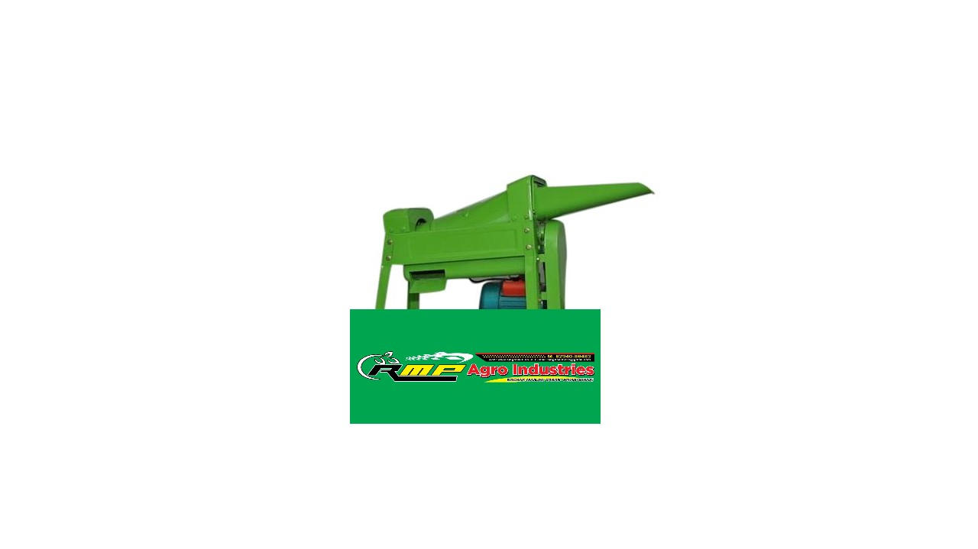 **Maize Thresher**

**Product Specification**

|  |  |
| --- | --- |
| Brand | Walson |
| Weight | 60kg ( With Motor) |
| Overall Dimensions | 760x440x1150mm |
| Rated Power | 2.2 kW |
| Rated Voltage | 220V-230V |
| Phase | Single phase |
| Standard Motor Speed | 2900R/min |
| Productivity | Greater than 140 kg/h |
| Spindle Speed | 1200 R/min |
| Minimum Order Quantity | 10 Unit |

**Product Description**

we are the manufacturer of mini corn threser which are motor operated. corn thresher avilable in 500 to 1200 kg.